Nguyễn Mạnh Bảo Tín MSSV: SE170134

Subject: DBI202 Class: SE1712

LAB 2

Đề Lab2.png (Quy tắc 1NF)

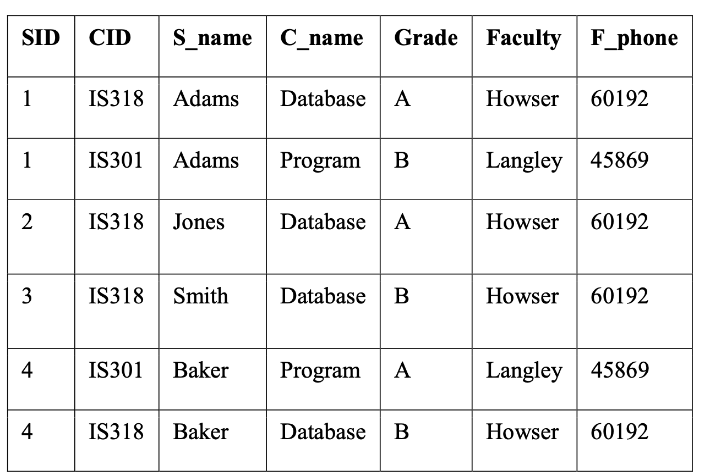

Quy tắc 2NF

Student table

|  |  |
| --- | --- |
| SID | S_name |
| 1 | Adams |
| 2 | Jones |
| 3 | Smith |
| 4 | Baker |

Information table

|  |  |  |  |  |  |
| --- | --- | --- | --- | --- | --- |
| SID | CID | C_name | Grade | Faculty | F_phone |
| 1 | IS318 | Database | A | Howser | 60192 |
| 1 | IS301 | Program | B | Langley | 45869 |
| 2 | IS318 | Database | A | Howser | 60192 |
| 3 | IS318 | Database | B | Howser | 60192 |
| 4 | IS301 | Program | A | Langley | 45869 |
| 4 | IS318 | Database | B | Howser | 60192 |

Quy tắc 3NF

Student table

|  |  |
| --- | --- |
| SID | S_name |
| 1 | Adams |
| 2 | Jones |
| 3 | Smith |
| 4 | Baker |

Grade table

|  |  |  |
| --- | --- | --- |
| SID | CID | Grade |
| 1 | IS318 | A |
| 1 | IS301 | B |
| 2 | IS318 | A |
| 3 | IS318 | B |
| 4 | IS301 | A |
| 4 | IS318 | B |

Class table

|  |  |  |
| --- | --- | --- |
| CID | C_name | Faculty |
| IS318 | Database | Howser |
| IS301 | Program | Langley |

Faculty contact info table

|  |  |
| --- | --- |
| Faculty | F_phone |
| Howser | 60192 |
| Langley | 45869 |